**A PROJECT REPORT**

**ON**

**“HYBRID-RECOMMENDER-SYSTEM-MAIN”**

*Submitted in partial fulfillment of*

*Masters in Computer Application’s*

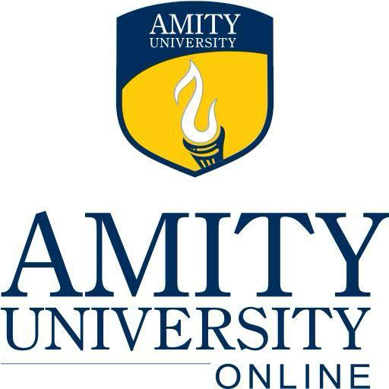

Session: 2022-2024

DEPARTMENT OF MASTERS IN COMPUTER APPLICATION’s

AMITY UNIVERSITY ONLINE

Submitted By:

AAYUSH SOLANKI (A9929722000500)